# **SMART CAMPUS ANALYSIS SYSTEM**

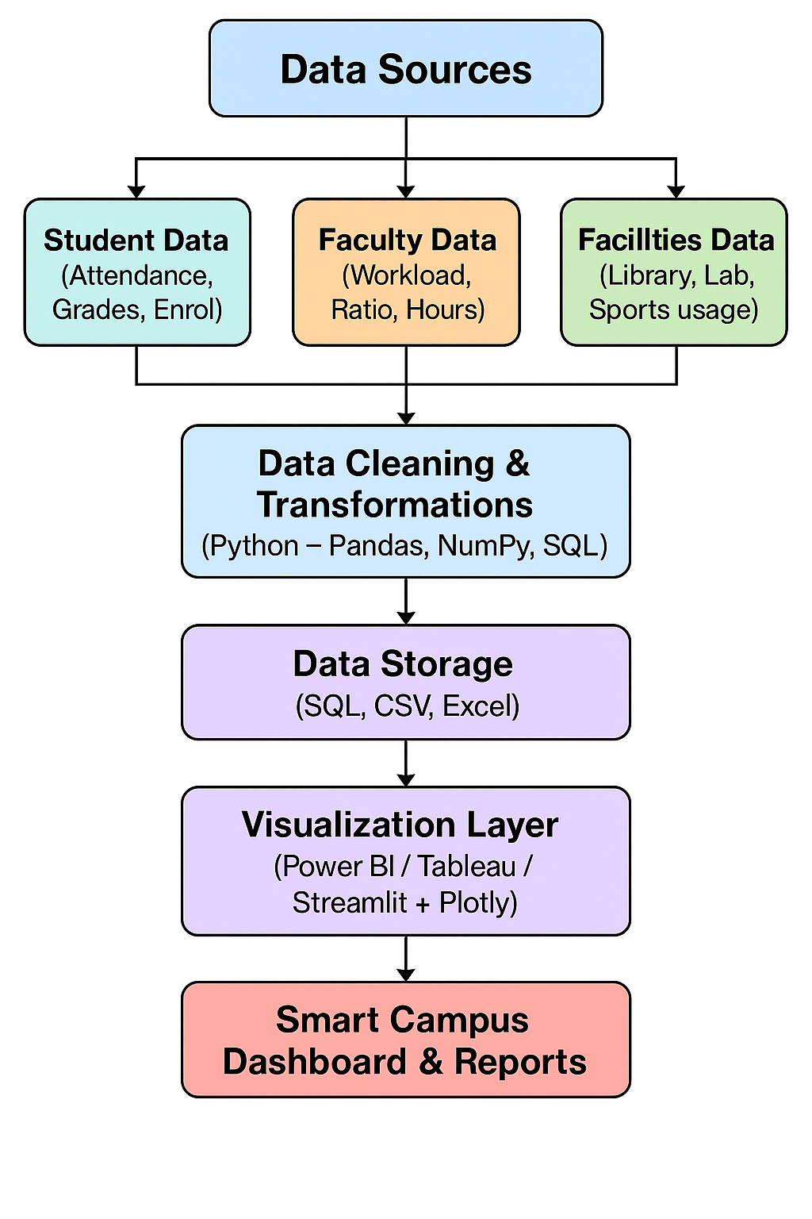**Basic Flow Diagram:**

# **Detailed explanation of each block:**

### **1. Data Sources**

This is the starting point of the system — where all raw data comes from. The sources include different domains within the campus.

* **Student Data:** Includes attendance records, academic grades, enrolment lists, dropouts, and program/course details.
* **Faculty Data:** Covers teaching hours, faculty-to-student ratios, subject allocations, workload distribution, and research contributions.
* **Facilities Data:** Includes information on library usage (book issues, e-resources), laboratory usage, sports facilities, hostel occupancy, and classroom utilization.

Purpose: To collect all necessary inputs for analysis.

### **2. Data Cleaning & Transformation**

Once raw data is collected, it often has errors, missing values, or inconsistent formats. This stage ensures the data is prepared for analysis.

* **Cleaning:** Removing duplicates, handling missing values, correcting wrong entries.
* **Transformation:** Changing formats (e.g., date to YYYY-MM-DD), normalizing scales, merging related datasets.
* **Tools:** Python (Pandas, NumPy), SQL queries for preprocessing.

Purpose: To ensure the dataset is reliable, accurate, and analysis ready.

### **3. Data Storage**

After cleaning, the data is stored in a structured format so it can be easily accessed later.

* **SQL Database:** Used for structured, query-friendly storage.
* **CSV/Excel Files:** Used for smaller datasets or sharing purposes.
* **Backup & Security:** Ensures data integrity and compliance with privacy standards.

Purpose: To organize and secure the cleaned data.

### **4. Data Analysis & KPI Calculation**

At this stage, analytical methods are applied to extract insights and calculate **Key Performance Indicators (KPIs)** relevant to campus performance.

* **Examples of KPIs:**
  + **Attendance %** = (Total attended classes / Total classes) × 100
  + **Pass Rate** = (Number of students passed / Total students) × 100
  + **Faculty-to-Student Ratio** = (Total faculty / Total students)
  + **Library Utilization Rate**, **Lab Occupancy Rate**, etc.
* **Methods:** Statistical analysis, trend analysis, comparison over semesters/years.

Purpose: To quantify performance and identify improvement areas.

### **5. Visualization Layer**

This stage presents the analysis results in a user-friendly, visual form.

* **Tools:** Power BI, Tableau, or Streamlit + Plotly for interactive dashboards.
* **Features:** Charts, graphs, filters, drill-down reports.
* **Advantages:** Makes complex data easy to understand for non-technical stakeholders.

Purpose: To make insights actionable and visually appealing.

### **6. Smart Campus Dashboard & Reports**

The final product — a central interface for administrators, faculty, and decision-makers.

* **Dashboard:** Real-time view of attendance, academic results, faculty workload, facility usage.
* **Reports:** Downloadable summaries for monthly, quarterly, or annual review.
* **Decision Support:** Helps plan resources, improve student engagement, and optimize operations.

Purpose: To provide a single platform for monitoring and decision-making.